How to Apply:

If you are attending a school in East Sussex, you can use the account that your school has set up for you. If you are unsure of your username/password, please speak to your Head of Year and they will help you.
If you are attending a school outside of East Sussex, you can apply by registering for an account using the following link:

https://www.careerseastsussex.co.uk/register

You will be greeted with 3 options. Please choose the one that applies.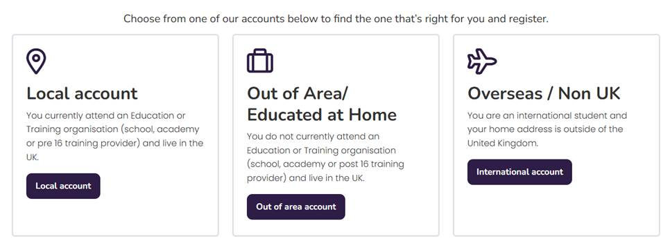

If you are within East Sussex and pick the first option, you will see the error message below:
