In this edition:

East Sussex Claimant Statistics –
Total number claiming Universal Credit (UC) any conditionality – 47,385 (September) and 47,945 (October).

Total claiming UC any conditionality as % of the working-age population – 14.9% (September) and 15.1% (October).

Number of claimants of UC searching for work or Job Seekers Allowance – 10,495 (September) and 10,465 (October).

UC/JSA searching for work % of the working-age population – 3.3% (September) and 3.3% October.
Source: East Sussex in Figures (ESiF)

All UC claimant rates living in East Sussex by conditionality and sex (October 2023)

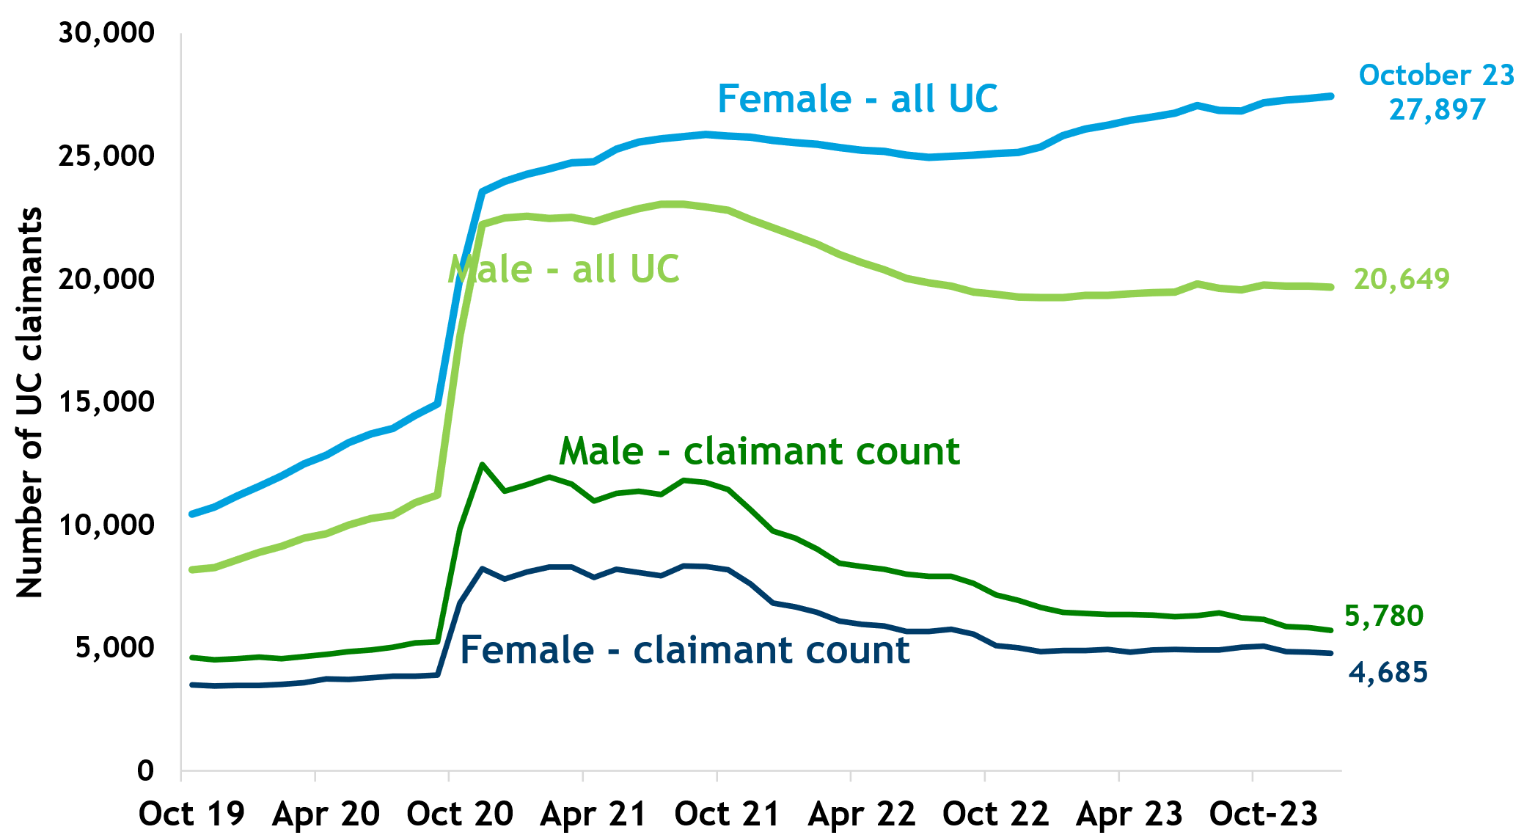

Graphs: Courtesy of ESIF

East Sussex Vacancy Statistics

Vacancies (unique job postings) by District for September/October

- Eastbourne – 3,843
- Wealden – 3,563
- Lewes – 4,326
- Hastings – 2,616
- Rother – 1,244

Top 5 Posted Job Titles in East Sussex (September and October)
- Care Workers and Home Carers
- Teaching Assistants
- Cleaners and Domestic roles
- Sales related roles
- Nursing

Skills demand in East Sussex
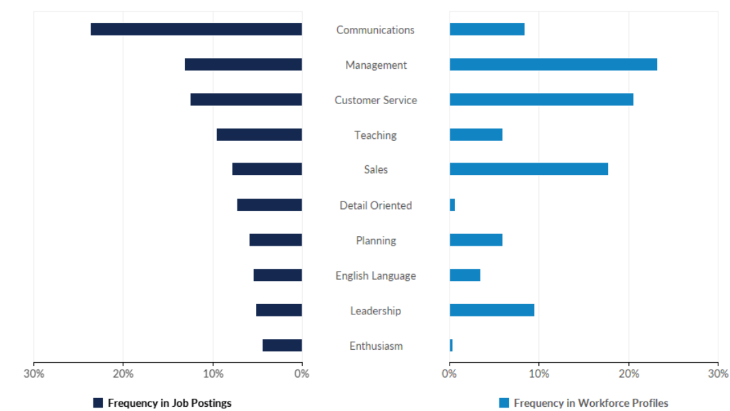

Source: Lightcast

Monthly Median Pay in East Sussex
Monthly median pay in East Sussex:
£2,109 per month using the HM Revenue and Customs Pay As You Earn Real Time Information in October 2023.
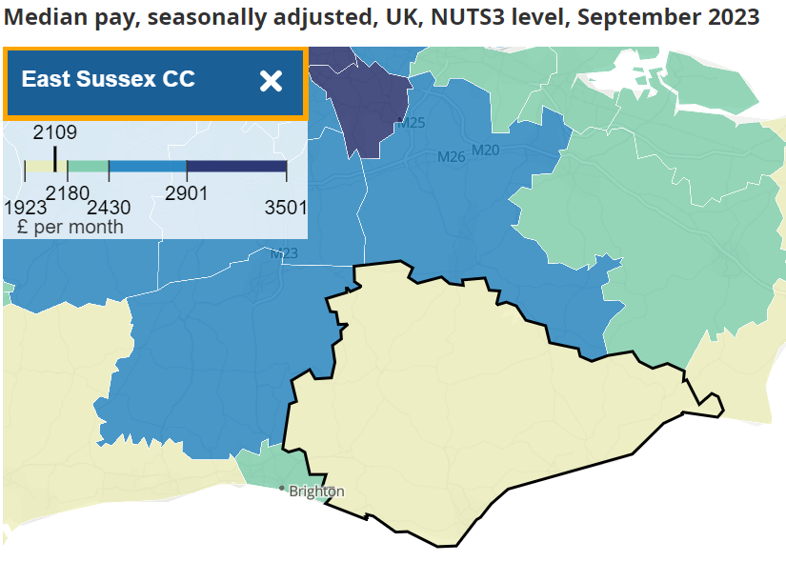
Source: Earnings and employment from Pay As You Earn Real Time Information, UK - Office for National Statistics (ons.gov.uk)

National Employment Picture
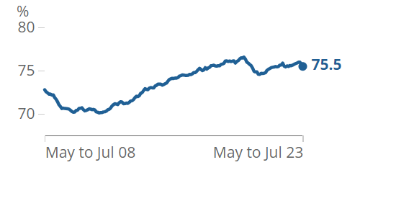
The national employment picture shows that between May to July 2023 the employment rate was around 75.5%. This was 0.5 percentage points lower than the February to April 2023 period.

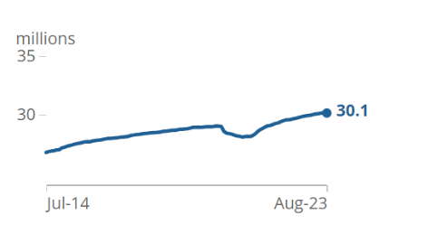
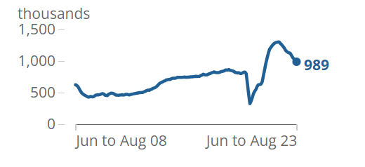

There were around 30.1 million payrolled employees in August 2023 and this is largely unchanged in the following months, but an increase is expected as we enter the festive period. In June to August 2023, the number of vacancies fell by 64,000 to 989,000.

Job Postings Nationally (21/11/23)

- London – 378,238
- South East – 403,807
- North West – 279,184
- South West – 239,174

Source: lightcast

Focus on – Public Sector

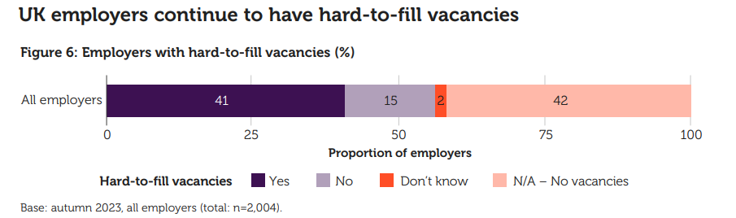
In June 2023 there were 5.87 million people employed across the public sector in England. This was an increase of 36,000 more than there were employed in the sector in March 2023 on the previous quarter. There were 3.67 million employed in central government in June 2023. This was an increase of 30,000 from March 2023. The NHS employed 1.96 million people in June 2023. This was an increase 21,000 whilst compared with March 2023. There were an estimated 2 million local government employees in June 2023.

The public sector is responsible for providing all public services in the UK. These services include education, emergency services, healthcare, housing, refuse collection, security, social care, and tax collection. Hard to fill vacancies are a key issue in the public sector with around 41% of public sector employers reporting they have hard to fill vacancies. Intention to recruit in the public sector in the UK is highest than across all sectors at 85%.

The Public Sector in East Sussex:
In 2022 there were approximately 35,184 people employed in the public sector across East Sussex.
Eastbourne – 10,112
Hastings – 8,551
Lewes – 7,782
Rother – 2,984
Wealden – 5,755

Careers in the Public Sector:
- Healthcare (e.g. paramedic, nurse, administrator, health service manager)
- Law enforcement and security (e.g. armed forces, fire service or the police)
- Social care (e.g. social workers, carers, community development worker)
- Teacher training and education (primary, secondary, or a higher education teacher)
Find out more about careers in the public sector on the National Careers Service website - Explore careers | National Careers Service

Seasonal work
Businesses often need extra help in the build up to Christmas and other busy times of year such as the summer months and shoulder seasons (Spring and Autumn). Seasonal work can offer a wide range of benefits for your future.
Benefits of seasonal work:
- Learn new skills
- Get work experience to build your CV
- Try out different jobs and sectors
- Try a different part of a company you already work for
- Decide if you are ready to go back to work after time off
- Earn some extra money

Check out the National Careers Service website for more information on finding festive jobs - Seasonal work advice | National Careers Service
Education and Training News
Sussex Chamber of Commerce are working with East Sussex County Council and other partners to create a retrofit Skills Plan for the East Sussex area.

Over the next decade, we will see significantly increased demand from the public sector and its partners for ‘retrofitting’ housing and other buildings in East Sussex. To prepare for this, it is crucial that we understand what our local employers, and those working in the supply chain with a specific focus on those in the construction sector are doing to improve their retrofit skills. To allow us to support them effectively through the skills plan we are developing.

We are seeking responses to the following survey questions by the 3rd December and can offer a £75 voucher to pay for or towards a retrofit related course at the East Sussex College Group Green Growth Hub to the first 150 respondents to this survey*.
In addition, we are exploring ways of offering subsidised learning to those who express an interest in the wider raft of available courses in East Sussex.
*The course needs to be booked Jan-March 2024.
Survey Link - Retrofit Skills Survey (surveymonkey.com)

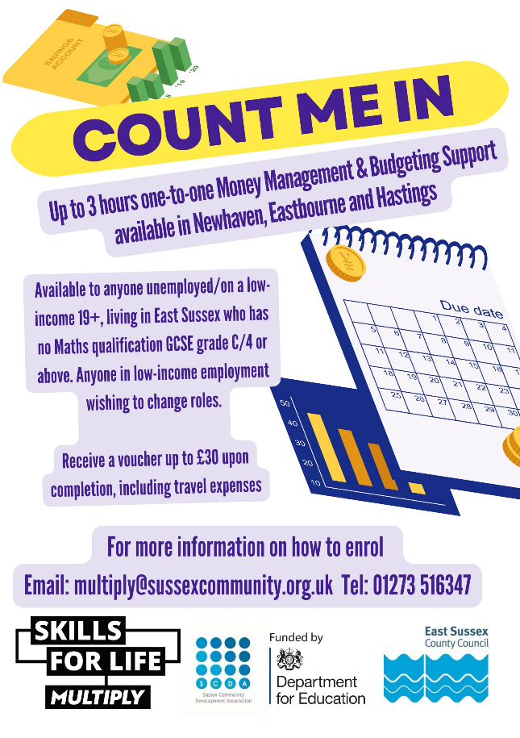
And Finally!
Check out this exciting opportunity for up to 3 hours one-to-one money management and budgeting support delivered by SCDA and as part of the Multiply project.
This is available for anyone unemployed/on a low income who is 19+, living in East Sussex who has no maths qualification GCSE grade C/4 or above.
Receive a voucher up to £30 upon completion, including travel expenses.
For more information or to enrol please email multiply@sussexcommunity.org.uk or telephone 01273 516347

Further useful LMI and Careers resources
- LMI For All - Explore LMI data – LMI For All
- Careers Hub - Careers > East Sussex (careerseastsussex.co.uk)
- Advice for Young People making choices Careers > East Sussex (careerseastsussex.co.uk)
- Advice for helping a child making choices - Careers > East Sussex (careerseastsussex.co.uk)
- East Sussex in Figures (ESIF) - Welcome to ESiF (eastsussexinfigures.org.uk)
- Office for National Statistics - Labour market overview, UK Statistical bulletins - Office for National Statistics (ons.gov.uk)
- Government funded training - Free courses for jobs - GOV.UK (www.gov.uk)

More links/further reading for this month’s topics

Note on economic inactivity given by the ONS:
- Other reasons for being economically inactive include those who are waiting for the results of a job application, those who have not yet started looking for work, those who do not need or want employment, those who have given an uncategorised reason for being economically inactive, or those who have not given a reason for being economically inactive.

